

Zeta Space Business Plan

And Whitepaper

Author: Professor Dr Lord Jack Rahman, Kt, PhD

Date : 30 November 2019

SKIPJACK CORPORATION

**Contents**

Executive Summary 3

Zeta SpaceOpportunity 4

Company Overview 6

Competitive Overview 8

Offerings 9

Differentiation 11

Marketing 12

Sales 13

Delivery 14

Financial Projections 15

Capital Requirements 18

Anticipated Valuation Impact 19

Risks and Mitigation 20

Executive Team 22

Overall Context & Contents

**This Zeta Space Business Plan is designed to enable the raising of financing via token in blockchain including the ZTN/USDT trading to aggressively pursue the Zeta Space business opportunity.**

**As is evident from an examination of all successful cloud players, the need to finance growth is primarily driven by the need to outlay cash upfront to aggressively acquire customers, and recapture that money over time based on subscription pricing. The more aggressively one seeks to acquire customers, the greater the financing requirement in order to achieve the growth rates sought.**

**A core assumption made by the Business Plan is that the Partner will seek token financing to aggressively expand its Zeta Space practice, because:**

* **Token financing is generally the least expensive form of financing available.**
* **Token financing is generally less restrictive in terms of the constraints it places on senior management and existing owners.**
* **Token financing does not require the effective divestiture of part of the company, by the existing owners, in order to make way for new shareholders.**

Directions: Executive Summary

**In this section we describe:**

* **The core demand that we seek to serve or sell into**
* **Why we are well positioned to capitalize on this demand**
* **What we require funding for**

# **Executive Summary**

Demand for IT services and infrastructure has fundamentally shifted towards the Cloud. Annual growth rates for Cloud solutions is eclipsing the growth of the IT industry overall and is projected to top $500 billion worldwide by 2023.

Skipjack bring new Space Computing bigger than a cloud business through an **autonomous data technology** to be as **Public Space (Cloud) Infrastructure** or IaaS (Infrastructure as Setrvice)

The new model offering the cloud by creating new technology in distributed storage and autonomous data will be a new disruptor to cloud business which currenly major player came from Microsoft, Google ,apple and Amazon. Skipjack Corporation build a new technology based on Jack’s law to provide the new Zeta Space bigger and more affordable with the new business model concept.

Skipjack Corporation is well-positioned to capitalize on this demand. We are a new technology leader in the provision of comprehensive storage solutions for small to mid-sized businesses, have a strong market presence, a compelling set of offerings, and the technical wherewithal to exploit this business opportunity.

However, in order to maximize our business potential, we require additional financing to aggressively acquire Zeta Space customers and crystallize our market share in advance of potential competitors. This Business Plan will detail how we intend to capitalize on this opportunity, the funding we will require, and the economic payoff that will result if we are successful.

1 Source: Worldwide and Regional Public IT Zeta SpaceServices 2013-2017 Forecast (IDC #242464)

Directions: Zeta SpaceOpportunity

**In this section we describe the overall demand for Zeta Space solutions, the reasons it is a significant**

**business opportunity, and summarize the financial gains you could achieve from aggressively developing a Zeta Space practice. If you have data available for your specific market use it, but the sample text below can be used almost verbatim in many cases.**

# **Zeta Space Opportunity**

Skipjack bring new Space Computing bigger than a cloud business through an **autonomous data technology** to be as **Public Space (Cloud) Infrastructure** or IaaS (Infrastructure as Setrvice) .Any discussion of this new technology industry today must start and end with Zeta Space computing. It is going to change the way in which technology is consumed worldwide, and the entire technology industry with it.

### **Zeta Space as Infrastructure as a Service (IaaS)**

An offering of Space computing where the provider supplies on-demand access to computing resources such as networking, storage, and servers via decentralised and distributed storage with autonomous data technology. Within the providers’ infrastructure, you run your own platforms and applications. This provides a flexible [hardware resource that can scale](https://kinsta.com/knowledgebase/traffic-spikes-surges/) depending on our storage and processing needs.

#### **Public Zeta Space**

A public Zeta Space is where the provider supplies with  access to the public distributed decentralised data centre infrastructure. They are responsible for all management, maintenance, security, and upgrades.

## **An Overview of the Cloud Computing Market in 2019**

The cloud computing market is huge. New data from the[Synergy Research Group](https://www.srgresearch.com/articles/half-yearly-review-shows-150-billion-spent-cloud-services-and-infrastructure), across seven key cloud service and infrastructure market segments, operators, and vendors – reports revenues in excess of $150 billion for the first half of 2019. A 24% growth on the previous year.

As big as the cloud market has become, there is massive scope for expansion. Especially when we consider[Gartner](https://www.gartner.com/en/newsroom/press-releases/2019-04-17-gartner-says-global-it-spending-to-grow-1-1-percent-i#targetText=The%20shift%20of%20enterprise%20IT,from%20%24399%20billion%20in%202018.) is projecting worldwide IT spending of $3.79 trillion in 2019.

A general term for anything that involves delivering a particular form of technology infrastructure or software application over the Internet, with multiple companies sharing application and hardware resources, Cloud computing is experiencing 5-year compound annual growth rates (CAGR) of 23.5%2 which is 5 times the growth of the IT industry overall. IDC, a renowned technology research firm, expects the overall Zeta Space services market will top $500 billion worldwide by 2023, as indicated in the following graphic.

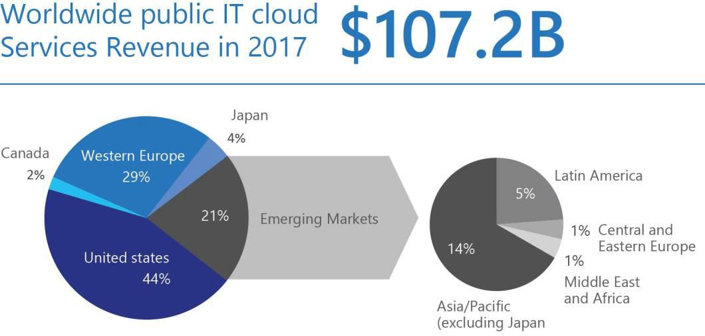

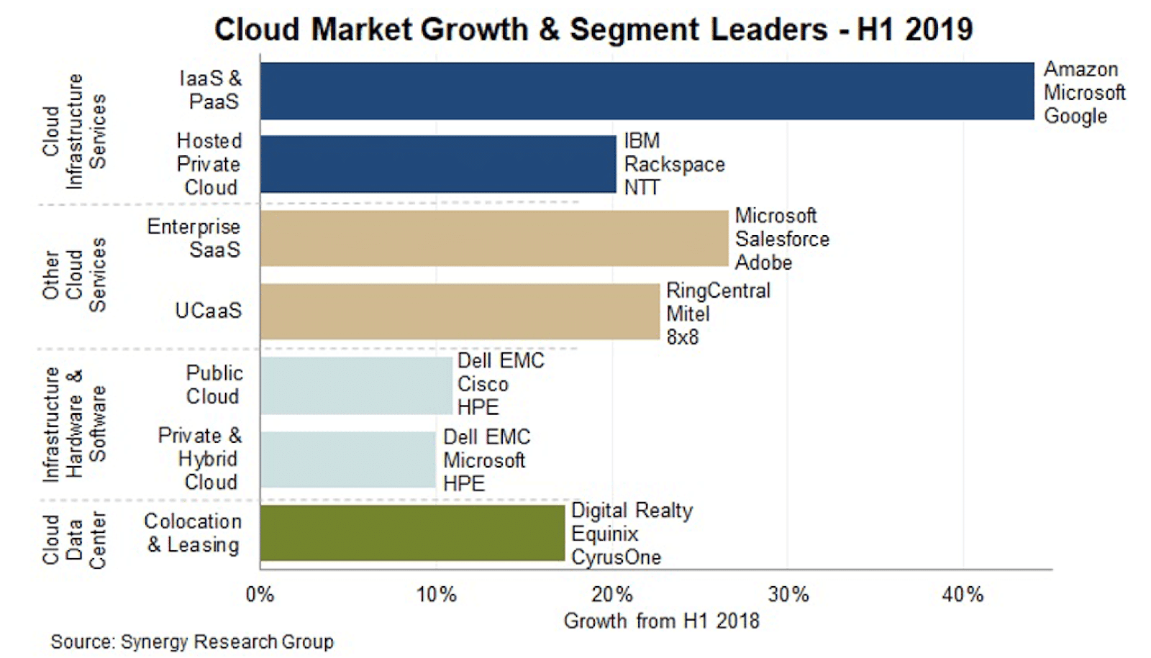

2 Ibid.

3 Ibid.

### **Which Provider Has the Largest Market Share in Public Cloud Infrastructure?**

The most recent[data from Gartner](https://www.gartner.com/en/newsroom/press-releases/2019-07-29-gartner-says-worldwide-iaas-public-cloud-services-market-grew-31point3-percent-in-2018) on the worldwide Infrastructure as a Service market shows annual revenues of $32.4 billion. A 31.3% growth from $24.7 billion in 2017.

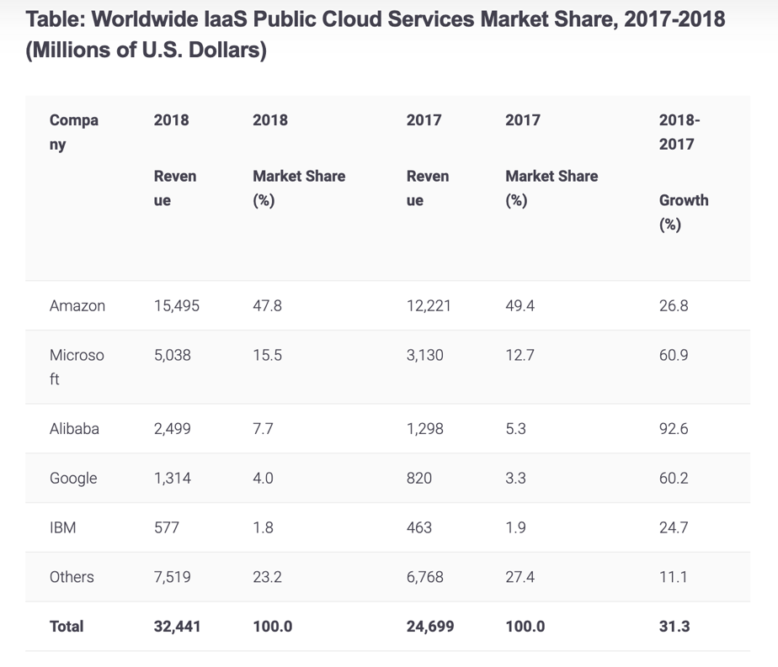According to Gartner, the market is dominated by five vendors who account for nearly 80% of worldwide IaaS cloud market share in 2018. These vendors are Amazon (47.8%), Microsoft (15.5%), Alibaba (7.7%), Google (4.0%) and IBM (1.8%).

The main reasons for the fundamental shift in customer demand towards Zeta Space computing are four-fold:

1. Zeta Space solutions require little or no capital outlay by the customer. Zeta Space offerings are consumed on a subscription basis with all aspects of the offering being provided by the supplier, thereby requiring no major upfront investments either in software or other licenses, or hardware.
2. Zeta Space solutions cost less. Because Zeta Space offerings are provided by larger entities that effectively aggregate volumes and thereby achieve scale economies unavailable to any mid-sized company, a customer can typically lower their overall technology costs.
3. Zeta Space solutions are more flexible. An organization can use as little or as much of any Zeta Space technology as is needed, scaling capacity up and down without incremental infrastructure costs.
4. Zeta Space solutions decrease risk. Because Zeta Space offerings are “evergreen” services, there is no risk of the technology becoming obsolete. A customer is always using the most recent version of any particular technology.

Skipjack Corp is well-positioned to capitalize on this demand. We are a leader in the provision of comprehensive technology in Internet 2 and blockchain solutions for small to mid-sized businesses, have a strong market presence, a compelling set of offerings, and the technical wherewithal to exploit this business opportunity.

While we are well-positioned, in order to maximize our business potential, we require additional financing in order to aggressively acquire Zeta Space customers and crystallize our market share in advance of potential competitors. This is a critical time, as Zeta Space computing moves into the mainstream. Those who obtain strong positions in their chosen niches first will be very difficult to displace later.

As is detailed later in this Business Plan, we estimate our incremental financing requirement to be in the order of

$50,000,000. We seek blockchain financing in this amount, in order to finance our customer acquisition efforts and make certain other critical investments in infrastructure. These we anticipate driving a period of negative cash flow lasting roughly 15 months, and being fully recaptured within a 26-month period.

If successful in our Zeta Space endeavors, we stand to significantly expand both our revenue and our business valuations. As this Business Plan will detail, we believe that successfully capitalizing on this business opportunity could over the next 4 years increase the value of our business by as much as $1.5-2.0b, as well as either position it for further growth by way of an IPO, or monetize our gains by way of a sale of the business.

Directions: Company Overview

**In this section briefly describe:**

* **How long your company has been in business**
* **How large your company is, in terms of employees and revenue levels**
* **What your company does**

# **Company Overview**

In business for over 2 years, Skipjack Corp sells, installs, and supports comprehensive technology fintech and IT solutions for small to mid-sized businesses. Headquartered in Singapore, our 50 employees serve in excess of 10,000 customers located across the 3 continents.

With annual revenues forecasting approaching $1350m by Quarter 4 , 2020, we have established a solid and reputable business providing our customers with the IT infrastructure they need to remain competitive.

Broadly, our offering set is comprised of the following:

* Zeta Space Readiness Assessments, which identify how a customer might best leverage the benefits of the Space compare to Cloud, and provide a detailed roadmap to achieve them, including the economic impact Zeta Space adoption would have.
* Exchange, Mailbox, and Server Migration, which implements the Zeta Space roadmap defined, ensuring value is delivered and full business benefits realized.
* Application Virtualization, which shifts key business applications to the Cloud, delivering far superior scalability and flexibility while lowering ongoing maintenance costs.
* Zeta Space Managed Services, which provide ongoing support for desktops, devices, applications, and workflows migrated to the Zeta Space.
* Zeta Space Backup, Storage, and Business Continuity, which ensures all data is secure and accessible, as well as that the business can seamlessly withstand any disruption.

Directions: Target Market

**In this section describe:**

* **The specific market(s) we will target**
* **The rough number of firms in the target market(s)**

**If at all possible, use local databases to more precisely define how big our target market is, but the real key is to give the reader confidence that your target market is large enough to support the financial projections laid out in a later section.**

**Target Market**

Over the years, Skipjack Corp has worked extensively with and developed particular knowledge of the unique business challenges faced by manufacturers, distributors, professional services organizations, and field services operators. It intends to fully leverage this expertise going forward, as customers expect industry-specific, out-of- the-box solutions in the Space.

Specifically, this provides Skipjack Corp with a total addressable market of roughly 150,000,000 retail users and 100,000 companies that meet its minimum annual revenue threshold.

New Technology: Whitepaper Summary

**In this section describe:**

* **The specific market(s) we will target**
* **The rough number of firms in the target market(s)**

**If at all possible, use local databases to more precisely define how big our target market is, but the real key is to give the reader confidence that your target market is large enough to support the financial projections laid out in a later section.**

Zetanet from Jack’s law: Blockchain Gen 5.0 for Internet 2.0 and Zeta Space

Professor Dr Lord Jack Rahman

***version 1.01***

Zetanet Abstract — A real secure communication has long been an import issue in recent years. To protect ones privacy, encryption was invented to help owners encrypt the data into meaningless information to non-receiver in order to prevent leakage. Since zeta series encryption in Jack’s Law provides more flexibility in information protection as it grows more attention, but effective methods are rare in this new research domain. In this blockchain 5.0 project, a multi-layered and authentication-enhanced scheme for information encryption based on Jack’s Law was created and its application focuses on encryption and autonomous storage. The scheme encrypts the whole or parts of the data according to its owners’ authorization by cryptography. Owners of the data can also specify their own permissions encrypted by hashing data based on their own private key as a signature in the data by embedding the corresponding authentication codes into the encrypted data. Later, the receivers can extract the hidden authentication codes to judge whether the decrypted data is authentic. The design applied in Zetanet is to demonstrate the effectiveness of the proposed Jack’s Law encryption scheme, and the conceptual framework for autonomous storage that can also be applied to other applications requiring information encryption especially in the new Internet 2.0 for blockchain.

**In digital word security is a most important issue and data hiding with image cryptography is one of the possible ways to ensure the security of the important message from outer world. In this paper we proposed a novel technique that encrypted the message such a ways that the message encoded as well as hidden in an image. The proposed solution is to use image cryptography to hide textual message. The proposed technique use of an encryption technique that is based on Fibonacci series & image encryption and a secret key generated from the image.**

The objective of cryptography is to make it feasible for two persons to exchange a message in such a way that other persons cannot understand. There is no end to the number of ways this can be done, but here the proposed method will be more concerned with a technique of encoding the text in such a way that the recipient can only discover the original message. The original message usually called plain text is converted into cipher text by finding each character in the message and replacing it with another character based on the Fibonacci number generated. Further cipher text is converted into Unicode symbols, which avoid suspicion from the third party when send through an unsecured communication channel. There are two levels in the proposed method; (i) converting plain text to cipher text and (ii) converting cipher text to Unicode symbols. In each level, security key is used to encode the original message which provides two levels of security from intruders. On the other end, the extraction algorithm is designed in such a way that the process converts the Unicode symbols into cipher text and then cipher text to plain text. This encoding and decoding scheme of the proposed method is significantly different as compared to the traditional methods. With the increase in the use of electronic transactions in everyday life, secure communications and data storage to withstand any kind of attack is warranted. The golden ratio, being the most irrational among irrational numbers, can be used in elliptic curve cryptosystems, power analysis security, and other applications. However, in such applications, cryptographic operations should take place very quickly before the keys are extracted or decoded by the attackers. This paper proposes an efficient method of golden ratio computation in cryptography to resist information security breaches. We compare our new golden ratio method with the well-known Fibonacci sequence method. The experimental results show that our proposed method is more efficient than the Fibonacci sequence method. Our golden ratio method with infinite precision provides reliable counter measure strategy to address the escalating security attacks.

**Index Terms**— Cipher text, Decryption, Encryption, Fibonacci Number, Key, Plain text, Unicode Symbols security, image cryptography, encryption technique, Fibonacci series, image encryption, secret key, Secret Sharing; Double layered Image Encryption; Tag Image; Access control

——————————  ——————————

1. INTRODUCTION

Zetanet project is a Blockchain 5.0 project lead by Skipjack Technology and the partners and in future may include a consortium of leading universities working in partnership with industry and the government’s. This Next Generation Internet (NGI) initiative is for developing a faster, more reliable Internet 2.0 for blockchain technology and communities including all over the world.

The Internet 2.0 Blockchain Initiative enables a new generation of emerging new applications whose architecture and development have been restricted by or are beyond the constraints of traditional Internet environments. These initiatives facilitate a variety of activities to foster the development and deployment of emerging applications that meet the requirements throughout the public sector.

Blockchain applications that work with high performance networks and supercomputing capabilities offer exciting new solutions for the internet industry. Internet 2.0 strive to combine the expertise of their constituents to establish a decentralised knowledge system for achieving innovation in research, teaching, learning, and commercialization. Zetanet as Internet 2.0 is an effort by Skipjack Technology to develop advanced Internet 2.0 technology and applications vital to the research and commercialization blockchain technology . Zetanet in partnership with blockchain industry and government, to provide leadership and direction for advanced Internet development. The “community” of Zetanet also includes international participation through agreements with similar groups worldwide.

1. HISTORY

Skipjack Technology leadership drives Zetanet Internet 2.0 with the demand for advanced applications and valuable expertise to implement initiatives. The combination of requirements and resources provides a perfect setting for developing the next generation of Internet capabilities. By accelerating the blockchain technology necessary to move the appropriate blockchain technologies into the commercial sector, Internet 2.0 provides both a next generation network and the applications that run on high performance decentralized networks.

Skipjack Technology invented **Jacks Law** and started the advanced application technology development has led to the introduction of Zetanet to be as Internet 2.0 initiatives by first released the **Encrypblock 1.0** technology in 2018. The Zetanet Initiative was created in January 2018 and allows members of Encrypblock 1.0 to find peers, work collaboratively, and share tools and other resources. Its goals include facilitating the creation and enhancement of blockchain applications whose development and deployment have been hampered or prevented by traditional Internet technology. Through the Zetanet Initiative the project work closely together to catalyze the development and deployment of advanced applications in the blockchain domain.

The internet, designed more than 40 years ago, has grown from little more than a research project to something that touches almost all digital interactions in the world. Although the core, lower-layer internet protocols have remained somewhat consistent since the 1990s, the internet’s application layer and server infrastructure have evolved tremendously to support the massive growth of internet applications.The primary model for building internet applications is the client/server model , popularized in the 90s. This model was a short-term blessing with long-term negative consequences. It enabled the Web to take off but caused Web services to become increasingly dependent on remote servers. Cloud computing is an evolution of the basic client/server model. Today, cloud providers stores private user data, run application logic and computations, manage access credentials, and so on.

Zetanet is an open-source effort to design, develop, and grow a zetanet network by integrating decentralized computing network that provides a full-stack alternative to traditional cloud computing. Zetanet is reimagining the transport layer of the traditional internet and provides a new network for decentralized applications; transport and applications layers built on Zetanet enable users to own and control their data directly into new internet. Zetanet creating new internet transport layer and underlying communication protocols while removing points of centralization in the application layer.

We follow the end-to-end design principle to keep the core of the network simple while pushing complexity to the clients. To scale the applications, we minimize global state changes and provide a reliable non decentralized storage system that gives comparable performance than to cloud storage. Further, our full-stack approach gives default options for all developer stack components necessary to build decentralized applications. Zetanet is modular, and developers can easily customize it and integrate alternative technologies.

This paper is a major revision of our earlier 2018 whitepaper and will incorporate the evolution of our design as to be design in production deployments and future feedback from application developers. This paper introduces the design of our new *Zetanet* blockchain, which is designed to enable blockchain run on top over zetanet , scale up decentralized applications and provide incentives to developers for building high-quality applications .We present a new smart contracting language, *Blowfish,* that optimizes for security in Zetanet (Section 3). We outline the design of the *Zetanet Autonomous Data* decentralized storage system (Section 4), our authentication protocol (Section 5), developer tools (Section 6), and highlight some ways in which application developers are currently using Zetanet (Section 7).

1. BACKGROUND ON ZETANET

In recent years, blockchain systems and their applications have expanded the boundaries of the crypto space and resulted in deeper decentralized application development. Bitcoin, Ethereum, Hyperledger Fabric, Corda, and other public and consortium chains have continued to emerge, creating a highly competitive environment. The research community required more functionality than existed in the Internet of the mid-90s. Responding to this need, in mid 2015, Skipjack started the research on fundamental of creating Internet 2.0. How we design the Zetanet to be a new Internet 2 is based on the encrypblock protocol that we created in 2017. EncrypBlock is a technology that has many application. One of which is through Financial Technology, Encrypblock can act as a Real-Time Gross Settlement and Security technology that allows a more secure and fast transaction that also scales up to more than 1,000,000 transactions per second. EncrypBlock Technology is built upon a zeta series internet protocol, and supports a new digital currency (encrypcurrency) that will represent fiat currency, cryptocurrency, commodities, or other units of value such as frequent flier miles or mobile minutes. Released in 2018, EncrypBlock Technology purports to enable "secure, instant, and almost free global financial transactions of any size with no chargebacks."

The Zetanet protocol suite provides an end-to-end data communication specifying how data should be packed, addressed, transmitted, routed, and received in the network topology of Zeta Series. This functionality is organized into abstract layers, which classify all related protocols according to the scope of networking involved. Encrypblock plans to be the core of all kinds of transactions especially in Financial institutions. With the development of blockchain technology and its applications, various problems have gradually been exposed. Issues such as the inability to scale for large-scale performance, the inability to support diverse business use cases, and the inability to exchange information and share assets across different blockchain networks have become more prominent.

In response to these problems, we are going back to the core values of blockchain technology. We want to solve blockchain’s current problems by improving some of the base-level issues – consensus algorithms, adding the new encryption protocol, ecological topologies, cross-chain agreements, underlying new network communication protocols, collaborative convergence computing, application ecosystems, and more, to promote the wider application of blockchain and Internet of Value technology.

1. VISION

The following major technological solutions:

* + A novel Zetanet Algorithm Protocol to improve speed, security and new concept autonomous data (zero storage) without loss performance in the fault tolerance to more 40% compared to Byzantine Agreement (BA) algorithms.
  + A Zeta Series Network (ZSN) architecture is a new network concept for nodes with high scalability and speed for use in a wide variety of application scenarios. This network will be secure, include resource isolation, and can be customizable for any demand.
  + Zetanet Protocol (ZP) and Zetanet Crypto Algorithm (ZCA) to aid in the naming, discovery, and addressing of Value Zetanet assets and entities. These seamlessly integrate with internet resources to build underlying protocols and infrastructure services for blockchain ecosystems.
  + A new protocol design TCP/UDP-based low-latency Zetanet Protocol (ZP) to better adapt to and meet the requirements of blockchain network interactions compared to the traditional internet TCP/UDP protocols used in current networks. Advantages include the ability to handle more connections, higher security, and lower latency, especially in the transmission of packets of a specific block size (1M, 2M). Compared with UDP, transmission efficiency can be improved nearly 1 order of magnitude.

There are many different types of decentralized systems in production today. The primary goal of Bitcoin, the first and currently the largest blockchain network, is to track and resolve the ownership of the Bitcoin digital currency. The goal of Ethereum is more general purpose: to construct a “world computer” to enable smart contracts and decentralized applications. Filecoin is an attempt to construct a network for decentralized file hosting and storage. In contrast, Zetanet attempts to realize *a blockchain internet* for decentralized computing, focusing on enabling secure, private applications where the blockchain layer handles minimal state and logic.

## **Design Goals**

The design of Zetanet optimizes for the following properties:

* + 1. **Ease of Use. Zetanet Internet 2.0** decentralized applications should be as easy to use for end users in internet 2 applications. Decentralized applications should be as easy to develop as developing on Zetanet.
    2. **Scalability.** Zetanet should support users at internet-scale, i.e., hundreds of millions to billions of users. The network blockchain 5.0 must scale with the number of users and applications it runs.
    3. **Autonomous Data and User Control.** Applications that use zetanet should put users in control by default. No dependent on servers operated by applications, users should be able to provide their computation and storage resources in autonomous data.
    4. **Minimal logic and state at the blockchain layer:** To achieve *scalability*, Zetanet minimizes application logic and data at our “zetanet” blockchain layer. Using blockchain operations for application logic and storage is inherently slower than “off-chain” approaches; the need to synchronize and validate state across a wide range of networks and devices imposes significant limits on the throughput of such operations. The limiting factor is underlying bandwidth for global connectivity and memory/storage available at typical network nodes, i.e., physical limitations (vs. any protocol limits).
    5. **Autonomous data storage changes:** The Zetanet network uses the full-stack approach to ensure that applications built on top are *scalable*: interactions in applications result in local state changes vs. global state changes whenever possible. Autonomous data to reduce storage system and new encryption authentication protocol are fundamental components of our network— they enable applications to interact with a user’s private data and authenticate a user without ever issuing a blockchain transaction. The zetanet blockchain is only used to coordinate global state transitions in a consistent way (such as registering a globally-unique username) in a decentralized fashion.
    6. **Reliable cloud-like storage vs. peer storage:** Applications built on Zetanet store data with the user (using their private data lockers) and don’t need to store any user data or access credentials at the server side. This approach not only puts users in control of their data but also reduces complexity for developers: developers no longer need to run servers and databases and pay cloud infrastructure bills on behalf of their users. Moreover, we avoid reliability and performance issues inherent with peer-to- peer storage and repurpose existing cloud storage providers in a decentralized wide-area file system — the blockchain layer only stores pointers to user’s data lockers. **Full-stack SDKs for developers:** Zetanet takes a “full-stack” approach and provides default options for all the layers required to develop decentralized applications. Developer SDKs abstract away the complexity of the blockchain and other technologies at work; application developers can build their applications with ease using interfaces of SDKs .Various layers of the developer stack are modular and can be used with other technologies as needed.

In addition to these differences from contemporary decentralized computing approaches, our smart contract language also makes unique design decisions to optimize for security and predictability of smart contracts (see Section 3 for details).

1. A NEW MODEL

## **A New Model for Applications**

Zetanet provides developers with a new model for constructing applications, ensuring that the applications are decentralized and put the users in control by default:

* + 1. **No opaque databases:** In the client/server model, databases are a core part of any application because the server-side needs to store and query large amounts of user data. In decentralized computing, developers don’t need to worry about maintaining and securing databases since they do not host data in the first place. Developers mostly focus on their app logic; users download the apps and plug- in their private data lockers. Databases, if used, are functionally equivalent to “search indexers” on the old internet— services which index public data. Anyone can create these indexes using the underlying (decentralized) data.
    2. **No servers:** In the client/server model, apps scale by adding more servers as computations for all users execute on the server side. In decentralized computing, apps run client-side, and each new user brings their computation and storage capacity to the network (rather than relying on the app developers). Developers only need to supply minimal infrastructure for hosting the application code, since each user brings the storage and computing resources they need to use the app.
    3. **Smart contracts:** In the client/server model, global state changes are coordinated by a central server which functions as the sole authority of truth in the network. In decentralized computing, these state changes occur through smart contracts executing on an open blockchain.
    4. **Decentralized authentication:** In the traditional internet, users authenticate using some trusted authentication process. If an application maintains a user database, the application authenticates the user with a password and sometimes a second factor. If an application relies on a third-party identity service, like Google or Facebook, it will use the OAuth protocol to obtain an assertion from that identity service. Of course, all these approaches remove control of the process from the users themselves. In decentralized computing, authentication is performed by the user’s client, by cryptographically signing a statement proving control over a particular username anchored to the blockchain. Any application can independently verify these proofs.
    5. **Native tokens:** In traditional internet applications, payment activities are usually performed using third-party services like credit cards. Digital tokens are a native asset of decentralized computing platforms like Zetanet and Ethereum. Users have direct ownership of these tokens and can use them directly to register digital assets and smart contracts, as well as pay for executing smart contracts. Use of such native tokens can be programmed through smart contracts to build subscription services and automate other app functionality. Such programmable tokens were traditionally not available to developers of traditional internet apps.

## **Layers of Decentralized Computing**

The Zetanet decentralized computing network logically exists at the “application layer” in the traditional internet design. However, the Zetanet network itself is composed of multiple systems which together provide the necessary components for implementing decentralized applications:

* + 1. **Zetanet Blockchain:** The foundation for the Zetanet network is the Zetanet blockchain which enables users to register and control digital assets like universal usernames and register/execute smart contracts. Digital assets like universal usernames, in turn, allow users to control their data storage and more—users link their access credentials for private data lockers with their universal usernames.
    2. **Autonomous Data:** The Autonomous Data storage system is a user-controlled storage system that enables applications to interact with private data lockers. Users can host these encrypted data lockers on a cloud-provider, local disk, or remote storage. Importantly, the *user* controls the choice of the underlying provider. Data on Autonomous is encrypted and signed client-side by the user’s cryptographic keys. Data lockers for users are discovered by looking up information on the Zetanet blockchain.
    3. **Zetanet Authentication:** The Zetanet Authentication protocol is a protocol for decentralized authentication with applications. This protocol enables users to authenticate using identities that they own and provide information about which Zetanet location should be used to store that user’s application data.
    4. **Zetanet Libraries and SDKs:** At the top of the software stack are the developer libraries and SDKs through which application developers and users interact with the various components of the zetanet network. For example, Zetanet client software allows users to register and manage their own identities. Zetanet’s developer libraries make it *as easy* for developers to build Zetanet applications as it is to create traditional web applications.

# **Zetanet Blockchain**

The Zetanet network’s foundational layer is the Zetanet blockchain. The Zetanet blockchain provides the global consensus and coordination layer for the network and implements the native token of the Zetanet network called the *Zetanet token*. Zetanet tokens are consumed as “fuel” when users register digital assets like universal user names, software licenses, pointers to storage lockers, etc. They are also used to pay miners for registering/executing smart contracts.

Jack’s Law Overview

1. JACK’S LAW PRINCIPLE OF MATHEMATICS

**The Theory of Jack’s Law – Definitions and Propositions**

* + - 1. We define a new Jack’s Law is a kind of cryptosystem using k -Fibonacci number. The invention of Jack’s Law The Golden cryptosystem was introduced by Fibonacci but was proven to be exist in the series that the long integer exist in the series for use in public-key encryption with the RSA algorithm. We will show that this new cryptosystem, which is a modification of the golden cryptosystem, is secure against chosen plaintext attack. The pervasive appearance of phi throughout the series we name as Zeta Series is define by some to be the signature of encryption,K , a universal constant of design used to assure the infinite.

Z(n) $Ξ{ K}^{ab}$

Jack’s Law is the observation that the encryption or secret key is exist in every Fibonacci series that we name now as Zeta Series. *Jack’s Law observed that the act of “part of the whole adding the whole onto itself” can be thought of as a “mathematical way of describing secret key recognition of being part of the quantum series.” In application, this would suggest that “when any zeta series as part of the network in quantum, and stays firmly in that perspective, then it will also become into a harmonic relationship with the quantum network. As the golden ratio define become in Phi relationship with the nature in the quantum series it represents the secret key or private key as encryption to infinite. This could suggest as a new encryption series for long integers.”*

* + - 1. The Jack’s Law scheme encrypts the whole or parts of the data according to its owners’ authorization by cryptography. Owners of the data can also specify their own permissions encrypted by hashing data based on their own private key as a signature in the data by embedding the corresponding authentication codes into the encrypted data. Later, the receivers can extract the hidden authentication codes to judge whether the decrypted data is authentic. The design applied in Zetanet is to demonstrate the effectiveness of the proposed Jack’s Law encryption scheme, and the conceptual framework for autonomous storage that can also be applied to other applications requiring information encryption especially in the new Internet 2.0 for blockchain

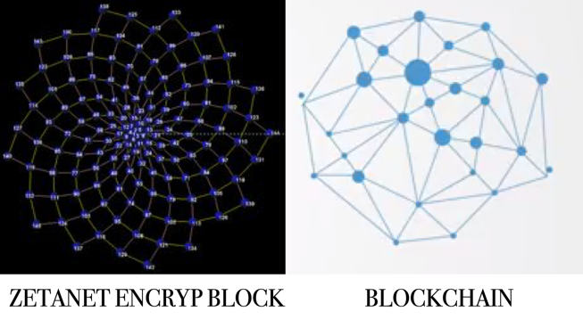

* + - 1. The number of network computing in a dense data doubles every two years. It also states that the connectivity, storage, speed and security will improve from the change of the protocol because of its algorithm and encryption. **Jack's *law*** *is the observation that the number of network computing in a dense of data doubles about every two years. The observation is named after the scientist of Skipjack Corporation, who’s in the Encrypcurrency paper described a doubling every year in the number of network connected per data network, and projected this rate of growth would continue for at least another decade. The period is often quoted as 18 months because of we predicted that network performance and efficiency protocols would double every 18 months (being a combination of the effect of more data and the network connectivity be more efficient and faster based on protocols and hardware improvement). This will be a problem solver of the increase of internet traffic that forecasts surge in IP traffic driven by number of factors, including growth of the Internet of Things*

In Jack’s Law, the series of Fibonacci now define as

**ZETA SERIES**

where every  **Zeta numbers** or **Zeta series** are **binary sequence** named after the mathematician Professor Dr Lord Jack Rahman who studied both that sequence and the closely related Fibonacci numbers. Zeta numbers and Fibonacci numbers form complementary instances of  Zeta binary sequences.

The Zeta binary sequence has the same recursive relationship as the Fibonacci sequence, where each term is the sum of the two previous terms, but with different interpretation of k constant in the series. This produces a sequence where the ratios of successive terms approach the golden ratio, and in fact the terms themselves are roundings of integer powers of the golden ratio. The sequence also has a variety of relationships with the Fibonacci numbers, like the fact that adding any two Fibonacci numbers two terms apart in the Fibonacci sequence results in the Lucas number in between.

Similar to the Fibonacci numbers, each Zeta number is defined to be the sum of its two immediate previous terms, thereby forming a  Fibonacci integer sequence .The first two Zeta numbers are *Z*0 = 00 and *Z*1 = 01 as opposed to the first two Fibonacci numbers *F*0 = 0 and *F*1 = 1. Though closely related in definition, Lucas and Fibonacci numbers exhibit distinct properties.

In mathematics and computing, **Zeta coding** is a universal code which encodes positive integers into binary code words. It is one example of representations of integers based on Fibonacci numbers. Each code word ends with "11" and contains no other instances of "11" before the end.

The Zeta code is closely related to the *Zeckendorf representation*, a positional numeral system that uses  Zeckendorf’s theorem and has the property that no number has a representation with consecutive 1s. The Fibonacci code word for a particular integer is exactly the integer's Zeckendorf representation with the order of its digits reversed and an additional "1" appended to the end.

The Zeta numbers may thus be defined as follows:

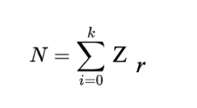For a number {\displaystyle N\!} N , if d (0),d(1),….., d(k-1), d(k) {\displaystyle d(0),d(1),\ldots ,d(k-1),d(k)\!} represent the digits of the code word representing {\displaystyle N\!}N then we have:

It is based on the Zeta sequence which now includes the initial 0.

The pattern in column one (the right-hand column) is derived from the rabbit sequence where *every "1" in the rabbit sequence has been replaced by "10"*:-

The zeta sequence:

010110101101101011010...

becomes:

0 1 0 1 1 0 1 0 1 1 0 1 1 0 1 0 1 1 0 1 0 ...

0 10 0 10 10 0 10 0 10 10 0 10 10 0 10 0 10 10 0 10 0 ...

which is **column 1** above, read downwards.

[N.B. This is exactly the same as if we flipped the bits (1 changes to 0 and 0 to 1) in the Zeta sequence (without its initial zero).However, there is a pattern in the other columns which is better seen with the description above.]

every "1" in the zeta sequence is replaced by "100" and every "0" is replaced by "00". 

0 1 0 1 1 0 1 0 1 1 0 1 1 0 ... Zeta Sequence

00 100 00 100 100 00 100 00 100 100 00 100 100 00 ... Column 2

where column 2 in the Table of Fibonacci representations is read downwards.

For column 3, replace "0" by "000" and "1" by "11000"  
For column 4, replace "0" by "00000" and "1" by "11100000"  
For column 5, replace "0" by "00000000" and "1" by "1111100000000"

{\displaystyle N=\sum _{i=0}^{k-1}d(i)F(i+2),{\text{ and }}d(k-1)=d(k)=1.\!}More precisely, if *N* is any positive integer, there exist positive integers *ci* ≥ 2, with *ci*+ 1 > *ci* + 1, such tha

It can be shown that such a coding is unique, and the only occurrence of "11" in any code word is at the end i.e. *d*(*k*−1) and *d*(*k*). The penultimate bit is the most significant bit and the first bit is the least significant bit. Also leading zeros cannot be omitted as they can in e.g. decimal numbers.

The first few Fibonacci codes are shown below, and also the so-called  implied probability distribution, the distribution of values for which Fibonacci coding gives a minimum-size code.

The sequence of Zeta numbers is:



All Fibonacci-like integer sequences appear in shifted form as a row of the  wythoff array ; the Fibonacci sequence itself is the first row and the Zeta sequence is the first row. Also like all Fibonacci-like integer sequences, the ratio between two consecutive Lucas numbers converges to the golden ratio



## **Meaning hidden in Phi, the symbol for the Golden Number?**

The use of the Greek letter Phi to represent the golden number 1.618 … is generally said to acknowledge Phidias, a 5th century B.C. sculptor and mathematician of ancient Greece, who studied phi and created sculptures for the Parthenon and Olympus. Today we understand the universe to consist of positive and negative atomic and subatomic particles and charges, matter and anti-matter, all coming from a singularity in what we term the “Big Bang. “Curiously, the mathematical constant of 1.618 … that is found throughout creation is represented by the symbol Phi, which is the symbol 0 for nothing split in two by the symbol 1 for unity and one”.  In the Jack’s Law the Phi is represent K constant number for encryption in the series.

## **Adding Unity to nothingness produces the Zeta series, which converges on Phi**

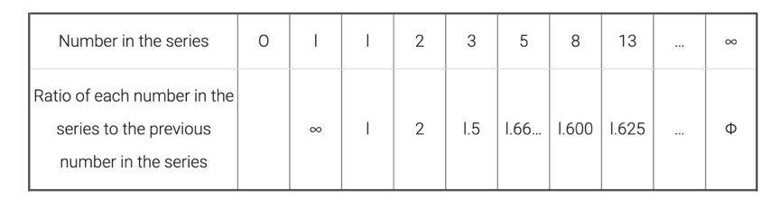In other words, add 0 plus 1 to get 1, and then follow this pattern to the Infinite.  This is the Zeta series.  The ratio of each number in the series to the one before it converges on Phi as you move towards infinity, ∞!

## **The Golden Proportion is analogous to encryption**

The Golden Section, or Phi, or K constant  found throughout nature, also applies in understanding the relationship to nature.  In the golden section, we see that there is only one way to divide a line so that its parts are in proportion to, or in the image of, the whole:

The ratio of the larger section (B) to the whole line (A) is the same as the ratio as the smaller section (C) to the large section (B):

## **The K constant in Jack’s Law Golden Section as a universal constant of design**

## The pervasive appearance of phi throughout the series is believed to be the encryption, a universal constant of design used to encrypt in the quantum network

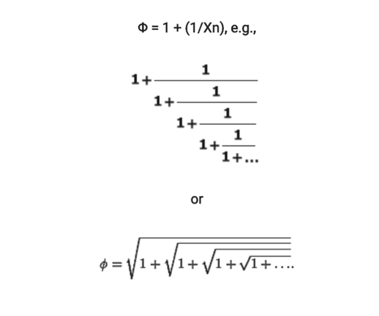Phi can be calculated in an iterative process, such as those shown in the equations below:

**Jack’s Law Key Exchange**

*Jack’s Law observed that the act of “part of the whole adding the whole onto itself” can be thought of as a “mathematical way of describing secret key recognition of being part of the quantum series.” In application, this would suggest that “when any zeta series as part of the network in quantum, and stays firmly in that perspective, then it will also become into a harmonic relationship with the quantum network. As the golden ratio define become in Phi relationship with the nature in the quantum series it represents the secret key or private key as encryption to infinite. This could suggest as a new encryption series for long integers.”*

The public-key encryption schemes that are mostly used today are RSA and ElGamal . Their security are based on the problems of factoring large composite integers or computing discrete logarithms. However, in [Sho97], Shor published an algorithm that quantum computers can use to solve both discrete logarithms and factoring in polynomial time. Therefore, it is important to construct new encryption schemes which are to remain secure even after the advent of quantum computers.

Given a Jack’s prime p = 2n − 1 (where n is prime), samples of the Zeta (Z) distribution are constructed as (a, b ) , where a ∈R Zp, the secret or private key and the error e are chosen uniformly at random from the elements in Zp .The decisional version of the Zeta assumption states that no efficient adversary can distinguish the Z distribution from a uniform distribution over Z2p.

Figure: The K constant

Despite the efficiency benefit of its reliance on Z primes. The new encryption here is still in the development for the zetanet quantum encryption.

In this paper, we present new Jack’s Law Key Exchange schemes for enhancing the information rate, this improvement is nonetheless significant in practice.

There exist groups for which computing discrete logarithms is apparently difficult. In some cases (e.g. large prime order subgroups of groups (**Z***p*)×) there is not only no efficient algorithm known for the worst case, but the average case complexity can be shown to be about as hard as the worst case using random self reducibility.

At the same time, the inverse problem of discrete exponentiation is not difficult (it can be computed efficiently using  exponentiation by squaring ,for example). This asymmetry is analogous to the one between integer factorization and integer  multiplication. Both asymmetries (and other possibly  one way functions) have been exploited in the construction of cryptographic systems.

Popular choices for the group *G* in discrete logarithm  cryptography (DLC) are the cyclic groups (**Z***p*)×  .While there is no publicly known algorithm for solving the discrete logarithm problem in general, the first three steps of the  number field sieve algorithm only depend on the group *G*, not on the specific elements of *G* whose finite log is desired. By  precomputing these three steps for a specific group, one need only carry out the last step, which is much less computationally expensive than the first three, to obtain a specific logarithm in that group.

This is the  concept of Jack’s Law Key Exchange algorithm. It is based on mathematics on binary Jack Encryption works by having two parties agree on two prime numbers: G and P. Each party individually selects a secret number: a for one party, b for another. They then raise G to the power of their given number, multiply it times the modulus of P, and transmit that result.

# When each party gets the result of their transaction, they raise that result to their selected secret number, multiply it against times the modulus of P, and suddenly now each is working with the same selected key thanks to the Laws of Exponents.

# In zeta series to breaking KEA is hard. Even if know P and G, finding the keypair for a,b requires to calculate a discrete logarithm. Without a quantum computer, we don’t know how to efficiently compute a discrete logarithm. We layer KEA in extra steps multiplication algorithm that authenticate each party and make sure that nobody is intercepting your traffic and shuttling traffic between you and your partner, it’s basically uncrackable.

# **Multiplication algorithm**

# A **multiplication algorithm** is an  algorithm (or method) to  multiply two numbers. Depending on the size of the numbers, different algorithms are in use. Efficient multiplication algorithms have existed since the advent of the decimal system.The basic idea is to use fast polynomial multiplication to perform fast integer multiplication. The algorithm was made practical and theoretical guarantees were provided in 1971 by Schönhage and Strassen resulting in the Schönhage–Strassen algorithm. The details are the following: We choose the largest integer w that will not cause overflow during the process outlined below. Then we split the two numbers into m groups of w bits as follows:

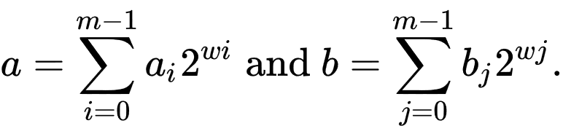

We look at these numbers as polynomials in *x*, where *x = 2w*, to get,

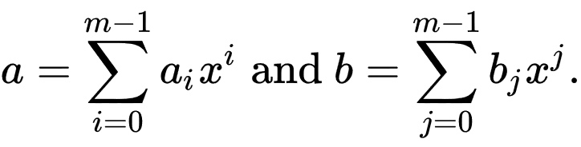

Then we can then say that,

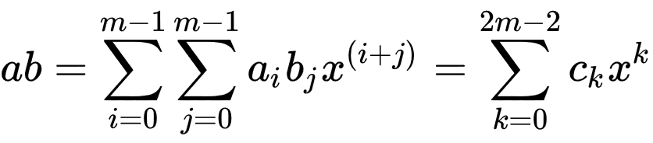

Clearly the above setting is realized by polynomial multiplication, of two polynomials a and b. The crucial step now is to use Fast Fourier multiplication of polynomials to realize the multiplications above faster than in naive O(m2) time.To remain in the modular setting of Fourier transforms, we look for a ring with a 2mth root of unity. Hence we do multiplication modulo N (and thus in the Z/NZ ring). Further, N must be chosen so that there is no 'wrap around', essentially, no reductions modulo N occur. Thus, the choice of N is crucial. For example, it could be done as,

N = 2 3 w + 1 {\displaystyle N=2^{3w}+1} N=2^{3w}+1

The ring Z/NZ would thus have a 2mth root of unity, namely 8. Also, it can be checked that ck < N, and thus no wrap around will occur.

The algorithm has a time complexity of Θ(*n* log(*n*) log(log(*n*))) and is used in practice for numbers with more than 10,000 to 40,000 decimal digits. To give a time complexity of *n* log(*n*) 2Θ(log*(*n*)) using Fourier transforms over complex numbers. a similar algorithm using modular arithmetic achieving the same running time. In context of the above material, what these latter authors have achieved is to find *N* much less than *23k + 1*, so that *Z/NZ* has a *2mth* root of unity. This speeds up computation and reduces the time complexity.

Using number theoretic transforms instead of discrete Fourier transforms avoids rounding error problems by using modular arithmetic instead of floating point arithmetic. In order to apply the factoring which enables the FFT to work, the length of the transform must be factorable to small primes and must be a factor of *N*-1, where *N* is the field size.

# **Large Integer Arithmetic**

An integer in C is typically 32 bits, of which 31 can be used for positive integer arithmetic. This is good for representing numbers up to about two billion (2 times 109).

Some compilers, such as GCC, offer a "long long" type, giving 64 bits capable of representing about 9 quintillion (9 times 1018)

This is good for most purposes, but some applications require many more digits than this. For example, public-key encryption with the RSA algorithm typically requires 300 digit numbers. Computing the probabilities of certain real events often involves very large numbers; although the result might fit in a typical C type, the intermediate computations require very large numbers.

* It turns out that, using a divide and conquer algorithm, one can obtain an algorithm that works in time (Nlg 3) = O(N1.59), much better than the quadratic time above. However, this technique only becomes efficient for very large values of N. There is another technique using the Fast Fourier Transform that multiples numbers in O(N log N log log N) time, which is even better, but still only becomes efficient for large values of N(e.g. > 10,000 decimal digits).
* A practical way to get more out of this algorithm is to increase BASE; this way, the same number of bits can be represented with less storage (i.e., lower value of N). The reason for choosing 10, other than the fact that it makes doing examples easy, is that it makes printing the numbers out a matter of traversing the array; other bases require complex conversions of bases. If we keep BASE as a power of 10 (e.g. 10,000), we can still easily print the numbers (fixing up leading zeros when we find them), and still improve performance.
* If we let BASE=2, then we are doing binary arithmetic. Multiplying by a single digit then becomes trivial: the partial product of n * A[0..N-1] is either all zeros (if the n=0) or A[0..N-1] itself (if n=1). This fact is not lost on computer architects, who implement multiplication algorithms in binary all the time :-)
* These are some simple arithmetic algorithms. There are other algorithms for integer division, subtraction (requiring a representation of negative numbers), exponentiation, modulus, etc. that are somewhat more complex but are basically the same idea. When we look at RSA encryption, we will assume a full implementation of large number arithmetic, being careful to take into account the various asymptotic complexities.
* If you would like to play with very large numbers, the Unix command bc implements "arbitrary" precision arithmetic; type bc at the command prompt and then type something ridiculously large like 2^1000 (2 to the 1000 power). The result will quickly come back.

Directions: Competitive Overview

**In this section we list who your main competitors are in the specific market(s) you will target.**

**For more ideas on identifying your likely competitors, review the video on Competitive Overview, here.**

**See sample copy below & delete this table when template is complete**

# **Competitive Overview**

Skipjack Corp has the following main competitors:

* Amazon Cloud
* Microsoft One Drive
* Google Cloud
* Apple iCloud

#### **Amazon Web Services (AWS)**

Owning almost half the world’s public cloud infrastructure market, Amazon is the clear market leader. In 2018, Amazon reported revenues of $15.4 billion, a growth of 26.8% on the previous year. Carrying this dominance into 2019, Amazon reports [Q1](https://press.aboutamazon.com/news-releases/news-release-details/amazoncom-announces-first-quarter-sales-17-597-billion) and[Q2](https://press.aboutamazon.com/news-releases/news-release-details/amazoncom-announces-second-quarter-sales-20-634-billion) combined AWS revenue of $16.1 billion, a 39% growth from H1 2018.

#### **Microsoft Azure**

With a market share at 15.5%, Gartner estimates Azure annual revenues of $5 billion and a growth of 60.9% in 2018. However, getting a true picture of Microsoft’s public cloud infrastructure market share remains a mystery. As Microsoft continues to mask Azure revenue in a combined “commercial cloud business”.

In 2019, Microsoft looks set to take market share from AWS, reporting H1 YoY growth of 70% in Azure revenues. Overall, Microsoft’s [Q1](https://www.microsoft.com/en-us/Investor/earnings/FY-2019-Q3/press-release-webcast) and[Q2](https://www.microsoft.com/en-us/Investor/earnings/FY-2019-Q4/press-release-webcast) combined commercial cloud business revenue is now reported to be $20.6 billion, a 40% growth on H1 2018.

#### **Alibaba**

Owning a 7.7% public cloud market share according to Gartner, Alibaba has annual revenues of $2.49 billion, and impressive growth of 92.6% in 2018. The Chinese ecommerce giant continues its impressive growth into 2019, reporting [Q1](https://www.alibabagroup.com/en/news/press_pdf/p190515.pdf) and [Q2](https://www.alibabagroup.com/en/news/press_pdf/p190815.pdf) combined revenues of $2.2 billion, a growth of 66%. This places the company’s annual revenue run rate in excess of $4 billion.

#### **Google Cloud Platform (GCP)**

[Google’s Cloud Platform](https://kinsta.com/blog/google-cloud-hosting/) is estimated by Gartner to command a public cloud market share of 4%, with annual revenues of $1.3 billion and growth of 60% in 2018. This year could see the Google overtake Alibaba, with Google CEO Sundar Pichai [reporting](https://abc.xyz/investor/static/pdf/2019Q2_alphabet_earnings_release.pdf?cache=3d0a3db) cloud service revenues on track for $8 billion. This needs to be taken with a pinch of salt as Google combines the GCP revenues with it’s SaaS G-Suite offering.

Make sure to check out our in-depth [Google Cloud Platform Market Share guide](https://kinsta.com/google-cloud-market-share/) to know more.

#### **IBM**

According to Gartner, IBM owns a 1.8% market share with annual revenues of $577 million and a growth of 24.% in 2018. Renowned primarily for its hybrid cloud services, IBM is set to shake up the market in 2019 having [acquired fellow IaaS provider Red Hat for $34 billion](https://www.redhat.com/en/about/press-releases/ibm-closes-landmark-acquisition-red-hat-34-billion-defines-open-hybrid-cloud-future).

Directions: Offerings

# **Product Offerings**

As briefly mentioned earlier, Skipjack Corp’s offering set is comprised of the following main elements:

## Zeta Space Readiness Assessments

Most customer engagements begin here, to identify how the benefits of the Zeta Space might best be realized. Depending on the company, several aspects of their IT infrastructure are considered, such as communications, collaboration, messaging, productivity, application development and maintenance, data center and other hosting requirements, security and identity management, mobile and other device connectivity, and software asset management to name but a few.

The end result is a quantification of the business impacts that a company could derive from Zeta Space adoption, as well as a staged roadmap to realize these economic and other business gains.

## Exchange, Mailbox, and Server Migration

For many companies, the journey to Zeta Space benefits starts with adopting Zeta Space when their current on- premises infrastructure can no longer support the needs of the business, and therefore must be replaced.

Through the use of automated tools and processes, Skipjack Corp ensures this initial migration is seamless and low- cost.

## Application Virtualization

As on-premises infrastructure ages, maintaining adequate computing capacity and minimizing ongoing operating costs become key concerns. By moving mission-critical and other key business applications to the Zeta Space, customers can reduce their total cost of IT ownership as well as gain greatly superior flexibility and scalability.

Skipjack Corp ensures that this process is smooth, reliable, and delivered at the lowest possible cost, both initial and ongoing.

## Zeta Space Managed Services

For many businesses, the desire to respond to competitive challenges and reap the benefits of the Zeta Space simply outstrips their internal IT department’s ability to deal with the increased complexity that results. To varying degrees depending on the size and operational complexity of the company, managing and maintaining Zeta Space infrastructure must be outsourced.

In many cases as well, a hybrid IT infrastructure will result, with some aspects in the Zeta Space and others remaining on-premises. Whatever the mix, Skipjack Corp provides the ongoing support to keep performance high and costs low.

## Zeta Space Backup, Storage, and Business Continuity

All businesses need to ensure that their data is secure and accessible, and that the business can continue in the event of any IT-related disruption.

Skipjack Corp provides a comprehensive service that automatically ensures all files and other key information is continuously backed up, and that a tested process for continuing the business is in place should a disruption occur.

## Zeta Space Creating $400 Million jobs

Europe will be our hub of innovation for our platformThe jobs created by the regional hub will result in a $400 million annual payroll in Zeta Space through giveback rewards program.It will provide a huge boost to our urban core with a positive wave that will spread across entire county and region.

The company plan to announce in Q1 in 2020 that it will launch Zeta Keeper in dozens of areas. Keepers are guaranteed with income from $500 per month.

It would team with hardware manufacturer to launch its newest self keeper industry. It can easily install its self-zeta space platform .

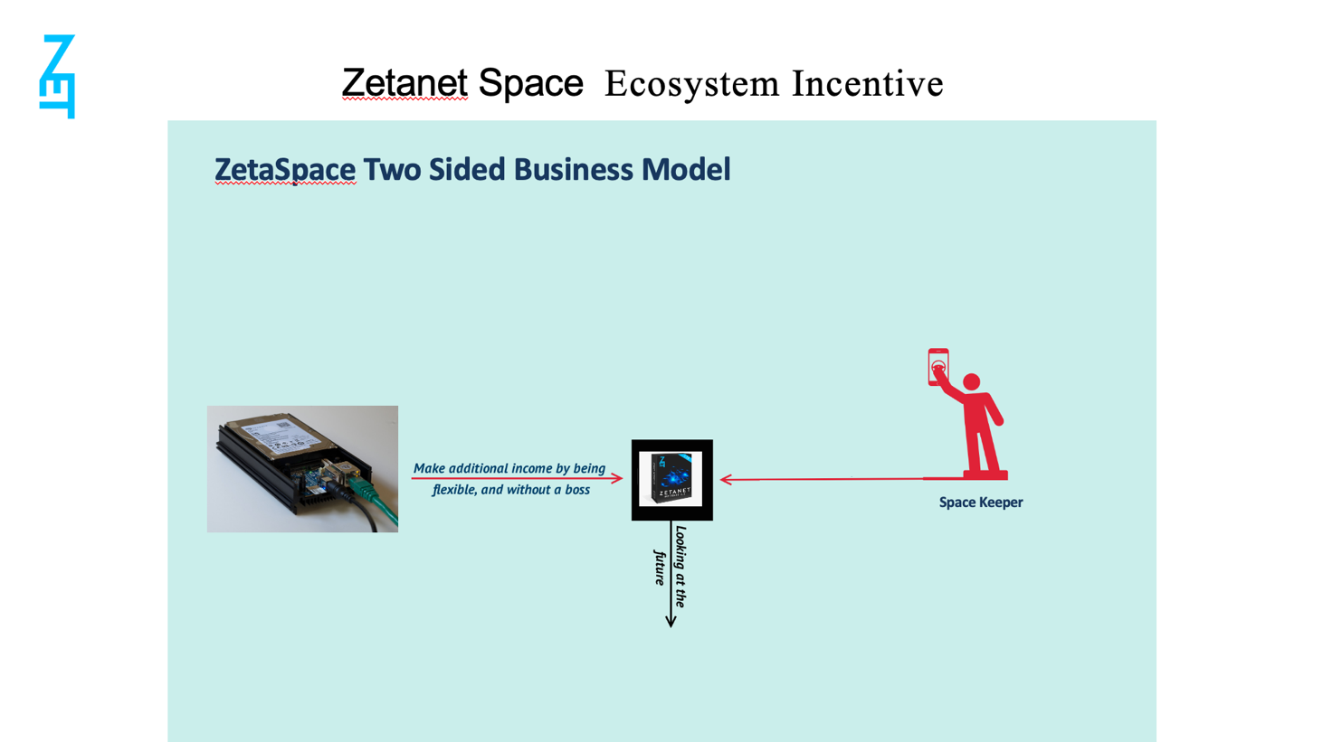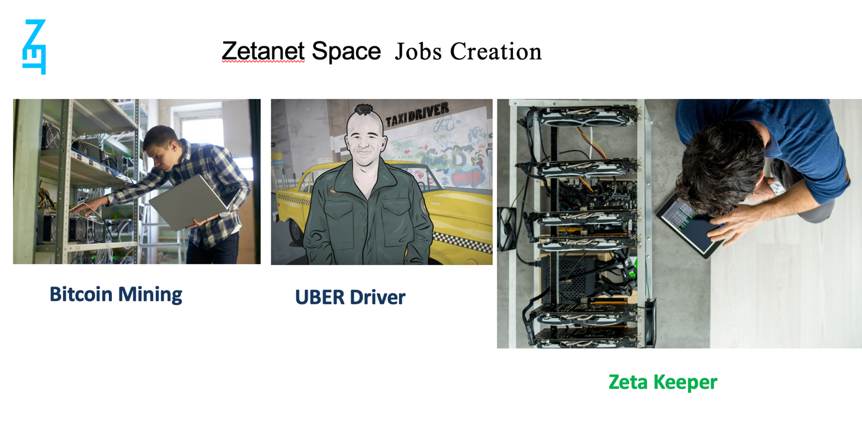

Directions: Differentiation

**In this section we describe what our core strategic strengths are, relative to the competitors earlier**

**described, and why they are inherently sustainable and cannot be easily replicated by these competitors.**

# **Differentiation**

Relative to these competitors, Skipjack Corp has the following competitive advantages:

* Unique Market Presence. In an industry that sees new entrants come and go with relative frequency, few players manage to achieve the longevity required to build true market awareness. Skipjack Corp, with over 2 years in business, has such a market presence. In the highly competitive IT industry, this market presence translates directly into an ability to source new prospects for their products and services both more easily and cost effectively than their competitors. Skipjack Corp is also better able to compete on a non-price basis, resulting in higher margins.
* Scale. With revenues expected to exceed $1.35 billion next Q4 2020, Skipjack Corp is in the top quartile of IT services providers, by volume. In order to reach this scale, numerous critical management structures and controls have had to be put in place, which smaller competitors simply cannot afford, not have the wherewithal to implement. These structures and controls lower unit costs with respect to both product and service delivery, and gives the organization more financial leverage, and greater stability, than smaller players. Additionally, because of the anticipated consolidation wave within the IT industry, larger players such as Skipjack Corp are in a far better position to grow their business, both organically as well as by way of acquisition.
* Industry Expertise. A key factor in meeting customer expectations lies in the ability to provide industry- specific solutions, either “out-of-the-box”, or by way of customization. Skipjack Corp has both the depth and breadth of expertise to provide these solutions to manufacturers, distributors, professional services organizations, and field services operators, among the most attractive market segments both in terms of total market demand, and profitability.
* Management Depth. Related to the achievement of a far larger than average scale is the incumbent management depth that was required to reach it. Smaller IT services providers are far more reliant on the continued presence of the owner, both to continue delivering consistent revenue streams, as well as keeping the entity profitable. Skipjack Corp has a management team in place which can continue to deliver solid financial performance, irrespective of its ownership.

Directions: Marketing

**In this section describe:**

* **The marketing strategy we intend to pursue in the Zeta Space**
* **The investments we will have to make to execute this strategy**

# **Marketing**

## Strategy

As the demand for Zeta Space solutions to be builds, Skipjack Corp needs to bolster its online demand generation capability in order to aggressively acquire Zeta Space customers and crystallize our market share in advance of potential competitors. This is a critical time, as Zeta Space computing moves into the mainstream. Those who obtain strong positions in their chosen niches first will be very difficult to displace later, and we wish to be among the former group.

Our strategy is to aggressively build an online marketing machine by making the investments mentioned below, and hiring dedicated online marketing resources.

## Investments

Specifically, Skipjack Corp intends to invest in:

* On-page search engine optimization (keyword research, keyword placement, title tags, meta descriptions, content layout, etc.)
* Community based Marketing
* Off-page search engine marketing (article writing, link building, press releases, etc.)
* Social media setup, training, and ongoing management
* Proprietary content creation (ebooks, guides, whitepapers, case studies, landing pages, new products, blogging)
* Multi-media content creation (webinars, videos, infographics, slideshares)
* Nurture marketing (email campaigns to nurture leads)
* Marketing automation

Skipjack Corp anticipates a requirement to invest $10m per annum over the next 4 years to meet the customer add projections later described in this document.

Directions: Sales

**In this section describe:**

* **The sales strategy we intend to pursue in the Cloud**
* **The investments you will have to make to execute this strategy**

# **Sales**

## Strategy

The rise in demand for Zeta Space solutions has been accompanied by a significant shift in buying behavior. Today’s buyer not only expects to find prospective suppliers online, but engages in considerable research before reaching out to them, and wishes to remain in control of their buying process throughout. At the core, this is the driving reason for the investment in marketing infrastructure just described.

But of equal importance is the need for a distinct Zeta Space-focused sales methodology, compensation structures, and indeed salespeople themselves. The strong industry experience is that “old school” sales processes and resources simply do not transition well to a Cloud-first world.

Our strategy is to aggressively build a largely remote sales force by making the investments mentioned below, and hiring dedicated Zeta Space sales resources.

## Investments

To meet our customer add projections, Skipjack Corp anticipates investing in:

* Recruiting, hiring, and training a dedicated Zeta Space-only sales resource
* Adaption of a CRM system to seamlessly disposition leads throughout the buying cycle, as well as integrate marketing with sales
* Ongoing management oversight of the Zeta Space sales function

Skipjack Corp anticipates a requirement to invest $10m over the next 1 years to fund this sales infrastructure.

Directions: Delivery

**In this section describe:**

* **The delivery strategy we intend to pursue in the Zeta Space**
* **The investments you will have to make to execute this strategy**

# **Delivery**

## Strategy

Although Skipjack Corp anticipates no need for large-scale hiring of technical resources to meet its customer add and revenue targets, it will have to invest in the training of existing resources. In addition, it must streamline and adapt many of its existing implementation and support business processes to be fully Cloud-relevant.

## Investments

Skipjack Corp anticipates a requirement to invest $10m per annum over the next 1 year to fund the following initiatives:

* Staff retraining in the latest Zeta Space technologies
* A revamping of our traditional implementation processes to be more streamlines and deliverable totally remotely
* A revamping of our support function to support the latest Skipjack technologies on an ongoing basis
* Training of our support function to more effectively cross-sell and upsell additional offerings

Directions: Financial Projections

**Using the Zeta Space Financial Models, we line our core anticipated financial impact from**

**executing the Business Plan. For a tutorial on how to populate the Zeta Space Financial Models..**

# **Financial Projections**

As Skipjack Corp executes its Zeta Space strategy, it anticipates the following deal structures, margin structure, customer add rates, and incremental infrastructure investments in customer acquisition and delivery.

Zeta Space Basic Assumptions

|  |  |  |  |
| --- | --- | --- | --- |
| (US$ 000) | First Year | Second Year | Third Year |

Zeta Space Best Scenario

ASEAN, China & India 3 billion usersUsers in 24 months 30 million

Users in 36 months 90 million

Advertising Cost US$ 44 millionMonthly Revenue US$ 0,5 /user/100 GB

|  |  |  |  |  |  |  |  |  |
| --- | --- | --- | --- | --- | --- | --- | --- | --- |
| Fast Growth | Quart 1 | Quart 2 | Quart 3 | Quart 4 | Sem 3 | Sem 4 | Sem 5 | Sem 6 |
| Users | 0 | 1 m | 3 m | 6 m | 10 m | **30 m** | 60 m | **90 m** |
| **Revenue** | 0 | 1.500 | 4.500 | 9.000 | 15.000 | 45.000 | 90.000 | 135.000 |
| Advertising | 3.000 | 3.000 | 4.000 | 4.000 | 7.000 | 7.000 | 8.000 | 8.000 |
| Management | 1.000 | 1.000 | 1.000 | 1.200 | 1.500 | 4.500 | 9.000 | 13.500 |
| Hardware | 2.000 | 2.000 | 500 | 450 | 400 | 350 | 300 | 250 |
| Software | 2.000 | 2.000 | 500 | 450 | 400 | 350 | 300 | 250 |
| Office | 300 | 300 | 300 | 300 | 600 | 600 | 900 | 900 |
| Gross Profit | -8.300 | -6.800 | -1.800 | 2.600 | 5.100 | 32.200 | 71.800 | 112.100 |
| ***Cumulated*** |  | *-15.100* | ***-16.900*** | *-14.300* | *-9.200* | ***23.000*** | *94.800* | *206.900* |

Zeta Space Worst Scenario

ASEAN 600 million usersUsers in 24 months 5 million

Users in 36 months 20 million

Advertising Cost US$ 26 millionMonthly Revenue US$ 0,5 /user/100 GB

|  |  |  |  |  |  |  |  |  |
| --- | --- | --- | --- | --- | --- | --- | --- | --- |
| Slow Growth | Q 1 | Q 2 | Q 3 | Q 4 | S 3 | S 4 | S 5 | S 6 |
| Users | 0 | 0,1 m | 0,5 m | 1 m | 3 m | **5 m** | 10 m | **20 m** |
| **Revenue** | 0 | 150 | 750 | 1.500 | 4.500 | 7.500 | 15.000 | 30.000 |
| Advertising | 1.000 | 1.500 | 2.000 | 2.500 | 3.500 | 4.500 | 5.000 | 6.000 |
| Management | 300 | 300 | 300 | 300 | 450 | 750 | 1.500 | 2.000 |
| Hardware | 2.000 | 2.000 | 200 | 200 | 300 | 300 | 300 | 300 |
| Software | 2.000 | 2.000 | 200 | 200 | 300 | 300 | 300 | 300 |
| Office | 150 | 150 | 150 | 150 | 450 | 450 | 600 | 600 |
| Gross Profit | -5.450 | -5.800 | -2.100 | -1.850 | -500 | 1.200 | 7.300 | 20.800 |
| ***Cumulated*** |  | *-11.250* | *-13.350* | *-15.200* | ***-15.700*** | *-14.500* | *-7.200* | ***13.600*** |

Zeta Space Business Plan

Based on the preceding core assumptions, and extensive financial modeling by Skipjack Corp, the 4-year pro-forma picture would likely be:

|  |
| --- |
| **Financial Projection**  Summary    Balance Sheet |







 









**COST OF PROJECT AND MEANS OF FINANCE**



**PROFITABILITY STATEMENT**



**CASHFLOW STATEMENT**















**VALUATION**



Risk-free rate is calculated using averages of asian, european and U.S. markets, based on 10-year government bond yield. Equity risk risk premium is calculated by using Moody's rating-based default spread. Beta is estimation based on other blockchain projects. The nature of the riskiness of the SKIPJACK's industry, additional 10% risk factor is added.

**17**

. Results

Directions: Capital Requirements

**Using the Zeta Space Financial models available here, indicate the capital you need and how you will**

**spend it. For guidance on sourcing options for the capital you need, review the video on Financial Leverage, here.**

# **Capital Requirements**

Based on the preceding assumptions and projections, Skipjack Corp anticipates a requirement of $50,000,000, distributed as follows:

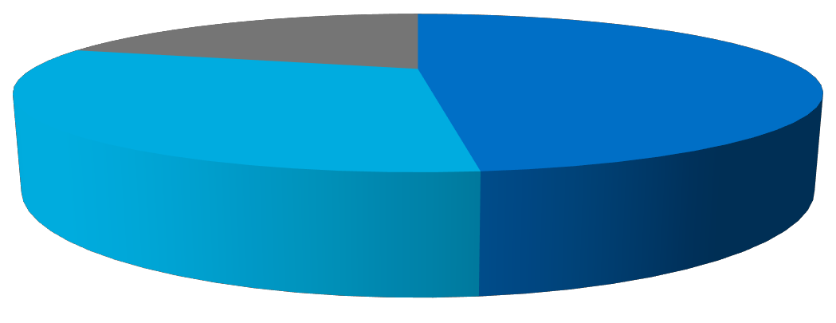

Marketing Sales Delivery

These funds are needed to make the needed infrastructure investments, as well as maintain an adequate buffer should cash flow projections be slower to materialize than expected.

Directions: Anticipated Valuation Impact

**Using the Zeta SpaceFinancial Models available here, indicate what the anticipated shareholder value**

**creation will be.**

# **Anticipated Valuation Impact**

In part, Skipjack Corp intends to pursue an aggressive Zeta Space strategy because the rise in Zeta Space computing will cause a dramatic shift in how companies in the IT industry are valued. Because Zeta Space solutions involve the purchase of ongoing subscriptions rather than upfront investments in hardware, software, and configuration services, valuation metrics tend to be driven by recurring revenue levels, and the margins that are driven by those revenue streams. One-time project services revenues, or one-time software revenue, are less highly valued. In today’s market, IDC sees the following valuation differentials for privately held IT services providers .

|  |  |  |
| --- | --- | --- |
| Potential Valuation | Traditional Revenue Business | Recurring Revenue (ZetaSpace) Business |
| Revenue Multiple | 0.2-1.5x | 6-9x |
| EBITDA Multiple | 2-2.5x | 9-15x |

Based on these metrics, and the adoption of this business plan, the estimated valuation of Skipjack Corp at the end of 4 years would lie in the $1.5 to $2.0 billion range.

4 Source: IDC Partner Valuation Study 2014, Doc # 249719.

Directions: Risks and Mitigation

**In this section list the key business risks that could affect the realization of the preceding financial**

**projections, and how you plan to reduce these risks.**

# **Risks and Mitigation**

The following are what we consider to be the potential risks associated with this Business Plan, and how we plan on mitigating them.

## Customer Acquisition Costs

Acquiring customers for Zeta Space solutions requires a significant investment in sales and marketing capacity, as earlier detailed. Should these investments not generate the volume of customer adds expected, customer acquisition costs will be higher than expected, relative to the revenue generated, and would create a greater than anticipated cash flow deficit.

To mitigate this risk, we have adjusted the capital we feel required to withstand such an event.

## Customer Retention

Because the long term financial returns for a Zeta Space business hinge heavily on customers renewing their subscriptions, and purchasing additional ones, any material customer “churn” will negatively impact overall financial results.

To mitigate this risk, we plan on bolstering our customer service and nurture marketing capabilities with the capital raised.

## Adverse Economic Conditions

Although demand for Zeta Space solutions is strong and growing currently, adverse economic conditions could negatively affect this demand, and so result in financial projections not being met.

There is also the distinct possibility that we may face price pressure from competitors seeking to establish themselves in our target markets, and effectively buying market share with lower prices than can be matched by ourselves, or indeed sustained over the long term.

To mitigate this risk, we plan on swift execution of this Business Plan, once the needed funds have been raised.

## Data Security and Privacy

Zeta Space solutions must be seen as secure in order to be saleable. Specifically, customers must feel their data is safe, and kept private. Any compromise of data security and/or privacy, even if not our direct responsibility, will negatively impact our ability to sell and market our solutions.

To mitigate this risk, we will offer products based on Skipjacktechnology (Space, specifically), which are recognized as the most secure available.

## Service Disruptions

Zeta Space solutions must be available 24/7/365, and any service disruptions will negatively impact our business. In addition, as with data security and privacy, we rely on 3rd. party suppliers to provide our customers with continuous access to their applications and IT infrastructure.

To mitigate this risk, we have chosen to partner with Microsoft for its reliability.

## Organizational Transition and Control

Moving to a Zeta Space delivery model is a significant organizational change, and represents a migration to a materially different business model. In order to fully complete this transition, management will need to be very skillful, as well as maintain control over the organization in the interim. We are confident we have in place both the required talent and organizational controls.

ZTN Distribution

**ZTN ISSUANCE AND DISTRIBUTION**

1. Token Distribution

A total of 5 billion ZTN will be issued, from which 2,100,000,000 will be offered to the market in two stages: presale and a public ICO.

Skipjack ZTN Token will be distributed as shown in the graph below:

(graph)

1. Token Sale Period
   * 1. Private sale – Ongoing
     2. Pre sale – 23 April 2019 to 31 August 2019
     3. Public sale – 1 September 2019 to 1 September 2020

A total of 5 billion **ZTN** will be issued, from which 42% or 2,100,000,000 ZTN will be offered to the market in two stages: **a presale and a public ICO** with 10% 500,000,000 for **Private sale**. 1 million token is available for bounty and rewards.

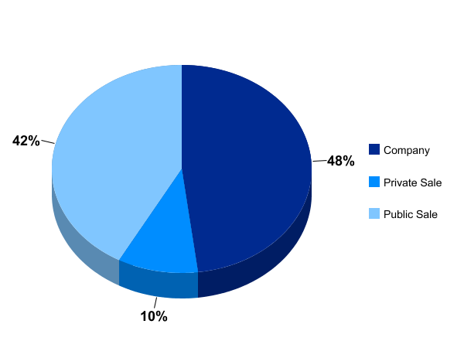

**ROADMAP**

|  |  |
| --- | --- |
| **Q1 2015** | Skipjack Research and Development  Development of Jack’s Law |
| **Q1 2017** | Development of new mathematical algorithm  New Digital currency (Encrypcurreny) Concept Design  New Blockchain Concept Design  Internet V2.0 Concept Design |
| **Q1 2018** | Birth of SkipJack Encrypcurrency |
| **Q2 2018** | Conceptual Design of desktop and Web messenger based on Encryblock (@doi) |
| **Q3 2018** | Technical Design for @doi |
| **Q4 2018** | Expansion Jack's Law in the storage and connectivity  Design the new network topology based on Jacks Law  Created the new zeta series for a high level encryption  Phase 1 of Encrypblock completed |
| **Q1 2019** | Development Zeta Space Concept |
| **Q2 2019** | Desktop and Web messenger launch (@doi)  Development of @doi for Mobile  The First Encryp Trading platform release  Public ICO starts 12 August 2019 |
| **Q3 2019** | Improve the development of Internet V2.0 (Zetanet)  Commence development for Encryblock based public ledger |
| **Q4 2019** | Development of Encryblock based customizable data management app for government and company usage called EncrypLedger  Completion of Encrypblock protocol and encryption for banking  Ecommerce integration to @doi accepting Skipjack dime as a payment for goods online. |
| **Q1 2020** | Launch of Zeta Space |
| **Q2 2020** | Completion of Symmetric key based Blockchain protocol  Voice Over Zetanet will be part of Telco |
| **Q4 2020** | ZetaSpace First Infrastructure to be completed |

**MEET THE TEAM**

Directions: Executive Team

**In this section provide brief bios of your senior management team.**

Meet the people behind the technology

Our team is composed of experienced and expert engineers, scientists, developers and strategists who are passionate about creating solutions that will change the way we view digital and finance.

|  |  |  |
| --- | --- | --- |
|  |  |  |
| **PROF DR SIR MIKE IRVAN**  Chairman and CEO APAC |  | **PAULIUS STANKEVICIUS**  CEO Europe and Middle East |
|  |  |  |
| **JOHN MOSES VENTURA**  Chief Technology Officer |  | **ADEM FIDAN**  Chief Finance Officer |
|  |  |  |
| **AMIT JOSHI**  Global Strategy Director & US Market |  | **IVAN LIM**  Director and Vice President TELCO |
|  |  |  |
|  |  |
|  |  |  |
| **KEMAL A. SURIANEGARA**  Business Strategic Advisor |  |  |

Legal

**LEGAL**

Skipjack Technology Pte Ltd ("Skipjack") maintains **https://zetaspace.io** its related sites for your information, reference and entertainment. Please feel free to browse, download from, contact us and otherwise use the site. At the same time, please remember that your access to the zeta space website is subject to the following rules (the "Rules") as well as all applicable laws.

By accessing and using the zeta space website, you accept and agree to the Rules without limitation or qualification, and acknowledge that any other agreements you may have with Skipjack are superseded by the Rules, to the extent any conflict exists.

Skipjack may at any time revise these Rules by updating this posting. You are bound by such revisions and should therefore visit this page to review the current Rules from time to time.

Skipjack Corporation reserves the right, without notice and for any reason, to remove any content on this site, and to deny access of any user or users to all or any part of this site.

**Use of the Site**

Unless otherwise specifically indicated, you may download material displayed on the Zeta Space website for personal, non-commercial use only and you may not distribute, modify, transmit, use, or reuse any of the contents of the Zeta Space website for any public or commercial purpose without the written consent from Skipjack Corporation or any third party Skipjack deems necessary. You must retain all copyright and other proprietary notices on downloaded and/or copied material. Any copy of material from the Zeta Space website you make and distribute for any purpose must also include these Rules.

You may not access or use the Zeta Space website in any way that could or is intended to damage or impair the Zeta Space website, or any server or network underlying the Zeta Space website, or interfere with anyone else’s use and enjoyment of the Skipjack Corporation Inc website.

**Copyrights, Other Rights**

You should assume that everything on the Zeta Space website is copyrighted unless otherwise noted and that it must not be used except as provided in the Rules or with the express written consent of Skipjack Corporation or any third party Skipjack deems necessary. SKIPJACK TECHNOLOGY NEITHER WARRANTS OR REPRESENTS THAT YOUR USE OF THE MATERIAL DISPLAYED ON THE SKIPJACKFCN  WEBSITE WILL NOT INFRINGE RIGHTS OF THIRD PARTIES. Any product, service, program, or technology described on the Skipjack Corporation Inc website may be the subject of other intellectual property rights (including but not limited to copyright, trademark, or patent rights) owned by Skipjack. Any such right that is not expressly licensed herein is reserved by Skipjack.

Images of people or places displayed on the Skipjack Corporation Inc website are either the property of, or used with permission by, Skipjack. Use of these images by you or other third parties is prohibited unless expressly permitted in the Rules or elsewhere on the Skipjack Corporation Inc website. Any unauthorized use of these images may violate copyright laws, trademark laws, the laws of privacy and publicity, and other applicable regulations and statutes.

Any product, service, program or technology described in any document published by Skipjack on this site may be the subject of other intellectual property rights owned by Skipjack. Any such right that is not expressly licensed hereunder is reserved by Skipjack.

To report copyright infringement and request that Skipjack remove any infringing content it is hosting (such as a Adoi user's profile picture, profile name, or status message), please email a completed copyright infringement claim to help@adoi.io (including all of the information listed below). You can also mail a complete copyright infringement claim to:

Skipjack Technology Pte Ltd

Level 39 Marina Bay Financial Centre Tower 2

10 Marina Boulevard

Singapore 018983

Tel: +65 6818 6063

Email: support@zetaspace.io

**Submissions**

Apart from your personal information (which is addressed in the Privacy Policy), any communication or material you send to the Skipjack Corporation Inc website, electronically or otherwise, including but not limited to data, questions, comments, suggestions, or submissions is and will be treated as non-confidential and non-proprietary. Anything you send to the Zeta Space website may be used by Skipjack Corporation for any purpose including but not limited to modification, reproduction, transmission, disclosure, publication, broadcast, and posting.

By submitting material to the Zeta Space website, you irrevocably transfer and assign to Skipjack, and forever waive and agree never to assert, any copyrights, "moral" rights, rights of publicity or to privacy, or other intellectual-property or proprietary rights that you may have in such material. Skipjack is free to use, without obligation of any kind, any ideas, concepts, techniques, or know-how contained in any communication you send to the Skipjack Corporation Inc website for any purpose whatsoever, including but not limited to developing, manufacturing, and marketing products and services.

By using this site, you may submit, or Skipjack may gather, certain limited information about you and your usage of the site. Subject to the terms of the Privacy Policy, Skipjack is free to use such information for any purpose it deems appropriate.

**No Warranties and Limitation of Liability**

To the maximum extent permissible by applicable law, Skipjack disclaims all warranties, express or implied, including but not limited to implied warranties of merchantability and fitness for a particular purpose. There is no warranty that any information or service provided or referenced by this site is either accurate, that such information or service will fulfill any of your particular purposes or needs, or that such information or service does not infringe on any third party rights. Except for any express warranties stated on this site, if any, the information and services provided or referenced on this site are provided "as is," “as available,” and with all faults, and the entire risk as to satisfactory quality, performance, accuracy and effort is with the user.

So while Skipjack may use reasonable efforts to include accurate and up-to-date information on the Zeta Space website, Skipjack makes no warranties or representations as to its accuracy, timeliness, or completeness. Skipjack may periodically add, change, or improve any of the information, products, services, programs, and technology described on the Skipjack Corporation Inc website without notice. Skipjack assumes no liability or responsibility for any errors or omissions in the content of the Skipjack Corporation Inc website.

In fact, your use of the Zeta Space website is at your own risk. To the maximum extent allowed by law, neither Skipjack nor any other party involved in creating, producing, or delivering the Skipjack Corporation Inc website is liable for any direct, indirect, incidental, consequential, or punitive damages, however caused, arising out of your access to, use of, or reliance on the Skipjack Corporation Inc website, even if Skipjack has been advised of the possibility of such damages. For example, Skipjack assumes no responsibility for, and will not be liable for any damages to or any viruses which may affect your computer equipment or other property on account of your access to, use of, or downloading from, the Skipjack Corporation Inc website. Please note that some jurisdictions may restrict or disallow the exclusion of implied warranties or limitations of liability, so some of the above exclusions and limitations may not apply to you.

**Other Agreements**

Your use of the Skipjack Corporation Inc website, or certain features or information provided through the Skipjack Corporation Inc website, may be subject to additional agreements apart from the Rules.

**Links**

Skipjack has not reviewed all of the sites which are linked to or from the Adoi website, and the fact of such links does not indicate any approval or endorsement of any material contained on any linked site. Skipjack is not responsible for the contents of any site linked to or from the Skipjack Corporation Inc website; and your connection to any such linked site is at your own risk.

**U.S., International Information**

Most of the information on the Zeta Space website applies internationally, but a significant amount of information applies only to certain countries or regions. Although Skipjack Corporation tries to mark all country- and region-specific information with a country indication, it does not warrant or represent that all information without indication applies internationally. You should check the applicability of any information on this site to you or your organization.

**Legal Information**

The Rules will be governed by and construed under the laws of the State of California, excluding only its conflict of law provisions. Each party to the Skipjack Corporation Inc website Rules hereby submits to the exclusive jurisdiction of the courts within the State of California, and waives any jurisdictional, venue, or inconvenient forum objections to such courts.

Any failure by Skipjack to enforce any of its rights under the Rules or applicable laws shall not constitute a waiver of such right. If any provision of the Rules is found by a court of competent jurisdiction to be invalid, you, Skipjack, and the court shall endeavor to give effect to the intent reflected in that provision, and the remaining Rules provisions shall retain their full force and effect.

You agree to follow any applicable laws in your use of the Skipjack Technology Pte Ltd website. Among other things, United States and foreign export control laws regulate the export and re-export of technology originating in the United States and such foreign countries. You will abide by these laws and regulations as applicable and will not transfer, directly or indirectly, by electronic transmission or otherwise, any content or software from the Skipjack Corporation Inc website to or from any countries or foreign nationals in violation of such laws or regulations.

Please note that the Zeta Space website is operated by Skipjack Technology Pte Ltd and not the various financial institutions that issue Skipjack cards. None of the terms of any agreement between a Skipjack cardholder and the financial institution that issued his/her card has any effect on or relation to these Site Rules.

Please also read over the Skipjack Corporation Inc website Privacy Policy, which are part of the Rules and which you accept.